TNT Renegades Lacrosse 2020 Annual General Meeting
October 17th, 2019
Attendees: Chris Petrie, Ray Bagley, Becky Morrissey, Robyn Michalak, Jessica Kuchurean, Stephanie Cehajic, Rijad Cehajic, Jeff Bernadino, Pamela St-Amant, Natrisha LaRocca
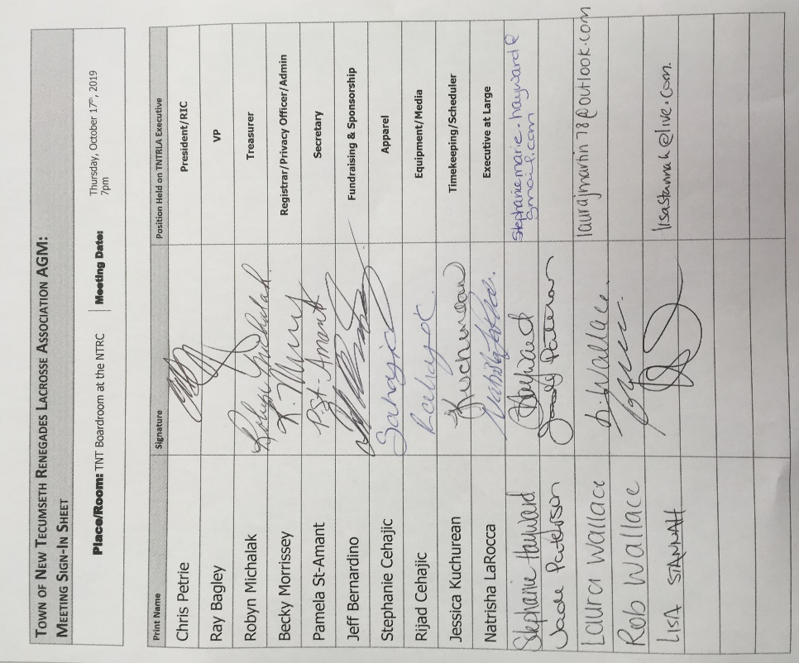

Meeting Commenced at 7:02pm

- Approve 2018 AGM meeting minutes: Minutes approved by Ray Bagley and Second by Becky Morrissey

- Words from the president and 2019 year in Review
Paperweight program was very strong. Membership fee was 50$ and Membership registration was also increased at 51 runners. Tyke, Novice, and Peewee all participated in the provincials. Our peewee 2 program participated in the Barrie house league for 10 weeks. We did not field a bantam and Midget team this year.

- Directors report
  - Apparel –Stephanie Cehajic
    - New Online store, we turned a profit. Clothing shipped directly to the homes.

  - Timekeeping/ scheduling – Jessica Kuchurean
    - First time as a scheduler and Timekeeper scheduler. All went well, we used the Tottenham, and NTRC. 6 timekeepers were used. We hope these timekeepers return. Shot Clocks have been replaced in Tottenham and NTRC.

  - Registrar – Becky Morrissey (see attached report)

  - Equipment – Rijad Cehajic
    - We only needed to invest into lacrosse balls. Goalie equipment needs to be updated.
  - RIC
    - All went well with the referees. We are still looking for a RIC. We hope to acquire one new referee in Calem Murphy. We ran our games with 5 Referees. Which we hope they all return.

  - Treasurer – Robyn Michalak (see attached report)
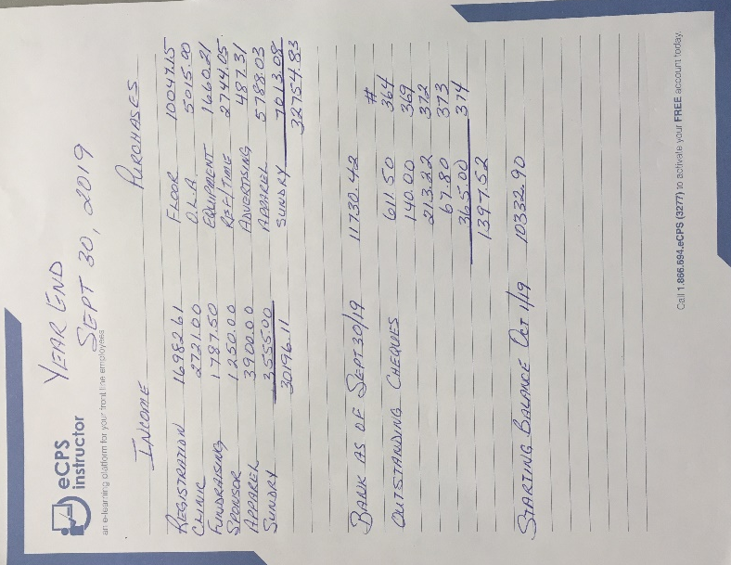
    - 700$ worth of pepperetts to be sold
    - 670$ in referee clinics to be paid to the OLA

  - Fundraising & Sponsorship – Jeff Bernadino
    - Pepperettes sold by all teams.
    - Moduloc, and Brake Works
    - Room for improvement for next year

- Constitution Amendments – none announced at this time

- Board Elections Positions for 2019
  - President – Becky Morrissey nominated by Ray Bagley, second Stephanie Cehajic and Chris Petrie
  - Vice President – Jade Paterson nominated by Ray, second by Pamela St-Amant
  - Secretary – Pamela St-Amant nominated by Natrisha LaRocca, second by Chris Petrie
  - Treasurer – Stephanie Hayward Nominated by Becky Morissey, second by Pamela St-Amant
  - Registrar – Laura Martin Nominated by Becky Morrissey and second by Ray Bagley
  - Referee in Chief - Pending
  - Apparel Director – Stephanie Cehajic is remaining in this position
  - Timekeeping Director – Jessica Kuchurean is remaining in this position
  - Equipment Director – Ray Bagley nominated by Jeff Bernadino, second Becky Morrissey
  - Coaching Director – Chris Petrie nominated by Ray Bagley, second by Pamela St-Amant
  - Fundraising and sponsorship – Jade Patersson nominated by Becky Morrissey and second by Ray Bagley
  - Scheduler – Jessica Kuchurean is remaining in this position
  - Media Director – Natrisha LaRocca and nominated by Ray Bagley and second by Jessica Kuchurean
  - Members at Large – Becky Morrissey nominates Jeff Bernadino, Lisa Stannah, Scott Paterson, Rijad Cehajic for members at large.

- New Business
-Becky Morrissey and Laura Martin will be attending the AGM
7. New Meeting date set for November 13th at 7pm
8. Meeting adjourned by 7:38pm

